THE TECHNICAL UNIVERSITY OF ŁÓDŹ

Faculty of Technical Physics, Information Technology and Applied Mathematics,

Information Technology

|  |
| --- |
| *Bachelor of Engineering Thesis*An analysis of min-max algorithm implementations in logic gamesPaweł CiążyńskiStudent’s number: 171120 |

###### Supervisor:

###### PhD Włodzimierz Mosorow

Łódź, 2016

POLITECHNIKA ŁÓDZKA   
Wydziałem Fizyki Technicznej, Informatyki i Matematyki Stosowanej

#### Paweł Ciążyński

#### PRACA DYPLOMOWA INŻYNIERSKA

Analiza implementacji algorytmu min-max  
w grach logicznych

Łódź, 2016 r.

Opiekun: Dr Włodzimierz Mosorow

**STRESZCZENIE**

Człowiek ma styczność z grami cały czas. Niekiedy nie zdaje sobie nawet z tego sprawy. Czy można nazwać grą moment, w którym człowiek śpieszy się do pracy i próbuje dojechać tam w krótszym czasie niż jego współpracownicy? To także może być grą, a jak każdą grę – można ją rozwiązać. W swojej pracy pragnę przedstawić czytelnikowi w jaki sposób można tego dokonać i co dokładnie znaczy „rozwiązać grę”. Praca jest podzielona na cztery części. W pierwszej części przybliżam czytelnikowi teoretyczne aspekty sztucznej inteligencji w grach logicznych. Wprowadzam różne sposoby rozwiązywania gier. W drugiej części przedstawiam na czym polega algorytm min-max, jego złożoność oraz różne odmiany. Trzecia część jest częścią praktyczną, gdzie przedstawiam implementację oraz działanie algorytmów dla dwóch gier logicznych. Ostatnia, czwarta część podsumowuje i analizuje wyniki działania różnych odmian algorytmu dla poszczególnych gier oraz prezentuje, która odmiana algorytmu min-max działa najlepiej.

TECHNICAL UNIVERSITY OF LODZ   
FACULTY OF *Technical Physics, Information Technology and Applied Mathematics*

Information Technology

#### Paweł Ciążyński

#### BSc THESIS

#### An analysis and comparison of differentmin-max algorithm implementations in logic games

Lodz, 2016

Supervisor: PhD Włodzimierz Mosorow

**ABSTRACT**

*[streszczenie po angielsku]*

**Content**

1. Introduction 6

2. Definitions 7

2.1. Definition of a game 7

2.2. Game tree 8

2.3. Definition of Artificial Intelligence 9

2.4. Solving games 10

3. Game solving Methods 10

3.1. How to solve the game? 10

3.1.1. Depth-first search (DFS) 10

3.1.2. Breadth-first search (BFS) 11

3.2. Comparison of DFS and BFS 12

3.3. Min-max 13

3.3.1. Basic min-max 13

3.3.2. Alpha cuts 13

3.3.3. Beta cuts 13

3.3.4. Alpha/Beta cuts 14

4. Project Implementation 14

4.1. Common code 14

4.2. Connect-four 14

4.2.1. Heuristics 14

4.2.2. Implementation 14

4.2.3. Results 14

4.3. Tic-tac-toe 14

4.3.1. Heuristics 14

4.3.2. Implementation 14

4.3.3. Results 14

5. Analysis of results 14

5.1. Connect-four 15

5.1.1. Computational complexity 15

5.1.2. Time complexity 15

5.2. Tic-tac-toe 15

5.2.1. Computational complexity 15

5.2.2. Time complexity 15

6. Conclusions 15

7. References 16

# Introduction

In these days, computers are very fast machines and can do tons of calculations in a split of second. However, sometimes these computers are not fast enough. The speed is sufficient for solving many small logic games like tic-tac-toe, but people also would like to solve very complicated games like, for example chess.

In my engineering thesis I want to present different approaches on solving logic games. Later on I will concentrate mostly on Min-max algorithm and its various implementations. I will write two games in java programming language (Connect Four and Tic-tac-toe). Then the goal of my thesis is to write and present how to solve the game and solve it using different variations of my Min-max algorithm. I do not aim to write perfect artificial intelligence program for these two games, but to present how these algorithms work in theory and in practice.

# Definitions

……………………………………….

## Definition of a game

A game is a physical or mental activity with set rules, in which participates one or more players. Games are undertaken for enjoyment and sometimes even used as educational tool.

There are different types of games. We can divide games into few categories while taking into account different aspects of them:

* Number of players:
  + No players (e.g. game of life)
  + One player (e.g. solitaire)
  + Two players (e.g. tennis, tic-tac-toe, chess)
  + More players (e.g. soccer)
* Amount of sum:
  + Zero-sum game (e.g. tic-tac-toe, chess) – it’s a game in which the gain (loss) of one player is a loss (gain) for another player.
  + Non-zero-sum game – a game in which the gain for one player does not necessary means loss for the opponent. Example of this game can be Prisoner’s dilemma or Battle of the sexes.
* Information to which player has access:
  + Complete information – situation in which the player has full knowledge about the board situation and strategies available to the other player.
  + Non-perfect information – player knows only some part of the board situation or moves available to his opponent.
* Determinism:
  + Deterministic (e.g. connect-four) – a game in which there is no random factor.
  + Non-deterministic (e.g. poker, dices) – random factor is a common thing in this game.

|  |  |  |  |  |
| --- | --- | --- | --- | --- |
|  | **Number of players** | **Amount of sum** | **Information** | **Determinism** |
| **Chess** | 2 | Zero-sum | Complete | Deterministic |
| **Solitaire** | 1 | Zero-sum | Non-perfect | Non-deterministic |
| **Game of life** | 0 | Non-zero-sum | Complete | Deterministic |
| **Soccer** | 22 | Zero-sum | Non-perfect | Non-deterministic |
| **Poker** | 2 – 8 | Non-zero-sum | Non-perfect | Non-deterministic |
| **Connect Four** | 2 | Zero-sum | Complete | Deterministic |
| **Prisoners’ dilemma** | 2 | Non-zero-sum | Complete | Deterministic |

Logic game is a type of game in which only matters intelligence of a player, ability to find best solution to the given problem. Unlike in physical games, logic games don’t need a player to be played (e.g. game of life).

## Game tree

A game tree is a graph which nodes represent states in the game and connections between them are different possible moves. These graphs are used to present and check all possible moves in subsequent turns.

Different games have got different graph complexity. It means that number of moves players can perform in each turn is different for each game. For example game chess has got a lot more complex graph than the game Connect-four. Graph complexity also depends on the round of the game. For example, in game tic-tac-toe, player who moves first can place his pawn on one out of nine fields, but next player can place his pawn on only one out of eight fields, etc.

Easy and simple way to estimate the games upper graph complexity is to count all possible states on the board. For example in the game tic-tac-toe, all possible states are all variations with repetitions with set of 3 elements placed on 9 fields. It gives us

V=n^k=3^9=19,183

different states.

However, this is only the upper estimation of graph complexity. Many games have got symmetric boards. It means that for each axis of symmetry we can divide the amount of states by two, because there exists exactly the same game state, but only rotated or reflected. For example, board of game tic-tac-toe has got four axes of symmetry (two diagonal, vertical and horizontal) and one axis of rotation.

## Definition of Artificial Intelligence

Artificial Intelligence (AI) is the ability of a computer program to perform humanlike actions and decisions. Artificial Intelligence can also act as an expert system, or a program for the perception and recognition of shapes.

In 1950 Alan Mathison Turing proposed that ability of a computer system to act as a human being in a conversation with other people can be a test for system’s intelligence. (Turing test).

John McCarthy for the first time coined term ‘Artificial Intelligence’ in 1955. He defined it as ‘the science and engineering of making intelligent machines'. In modern world AI is used to solve many different problems, such as acting as an expert system, data mining, logistics, voice recognition and many others.

## Solving games

In 1913 Ernst Zermelo published an article in which he analyzed the game chess and if for each position on the board there is a mathematical way to determine result of the game (win or loss) and to determine next best move for a player. However Zermelo didn’t answered if the starting position does provide a win for any player, he also stated that if it was a true statement, playing chess would be pointless, because each time we would know the winner even before the start of the game.

What does it mean to solve a game? Solving a game means that we found set of moves that will lead the player to the end of the game with this players win, despite of his opponents’ moves.

# Game solving Methods

…………………………………………………..

## How to solve the game?

There are many ways to solve the game. In my thesis, I will only concentrate on searching graphs of games. Computer algorithm can create all possible moves, that players can take and then search through the graph. There are also many ways to find the solution of the graph. We can divide them into two main groups of algorithms: Depth-first search (DFS) and Breadth-first search (BFS).

### Depth-first search (DFS)

This algorithm moves from the top of the graph to the bottom in vertical direction. Algorithm begins from root node (current state of the game) and checks its first child (first possible move from this state of the game). Then it checks the first child of the next node, and so on. When algorithm reaches the state in which there are no more children of currently visiting node, it goes back to the point where it could choose different path. This algorithm usually finds the solution pretty quickly, however it most likely will not be the most optimal solution.

[graph, description]

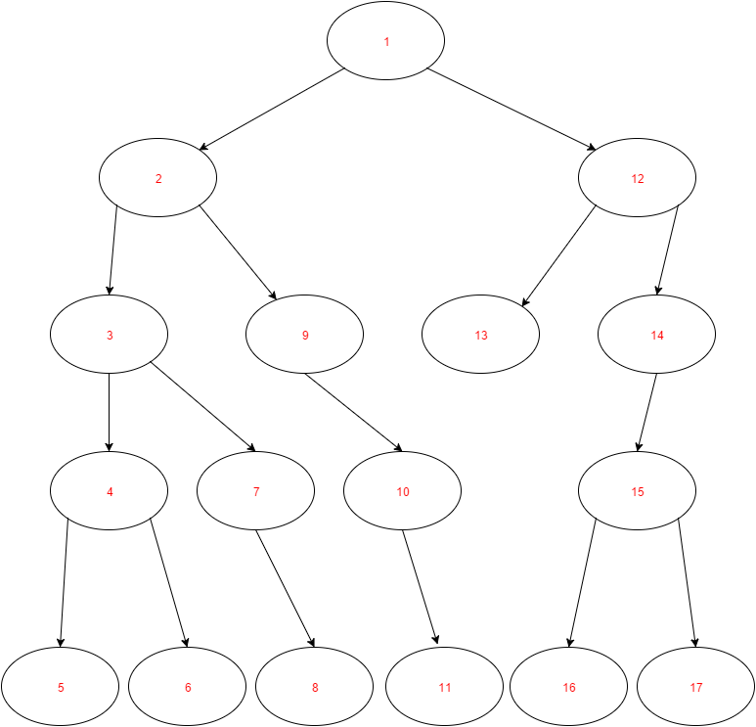

### Breadth-first search (BFS)

In this method computer moves from the top of the graph (current state of the game) to the bottom in horizontal direction. It means that algorithm visits neighbor nodes before it progress to visit child nodes in the graph. Using this algorithm we are certain to find the shortest possible solution.

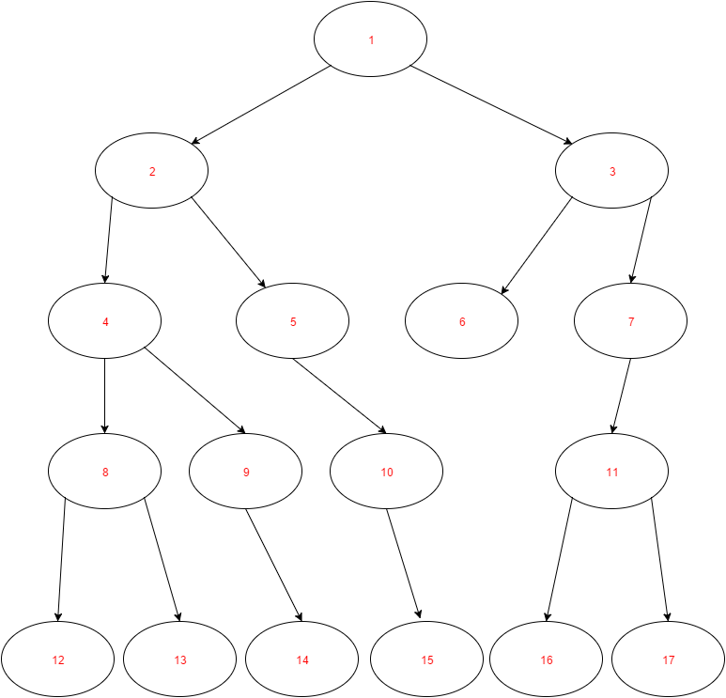[graph, description]

## Comparison of DFS and BFS

Depth-first search and Breadth-first search are two different approaches for graph searching. Time of finding expected node in the tree depends on the given graph. Let us consider the graph below. This is purely random generated graph in which we want to find the node with value greater than 100.

At first let us analyze with DFS algorithm. As we can see, it finds the node with value greater than 100 after checking 5 nodes.

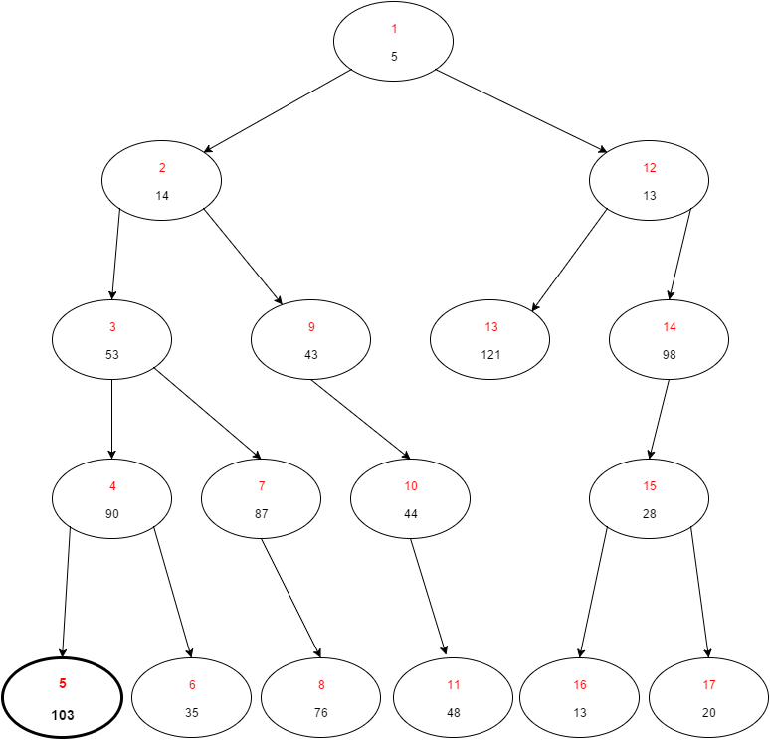

Now let us consider solving the same problem with BFS algorithm. Using BFS approach we found desired node in after checking 6 nodes. Also, this time we found completely different node with value greater than 100. It is due to the fact, that we first check all the nodes which are children of given node.

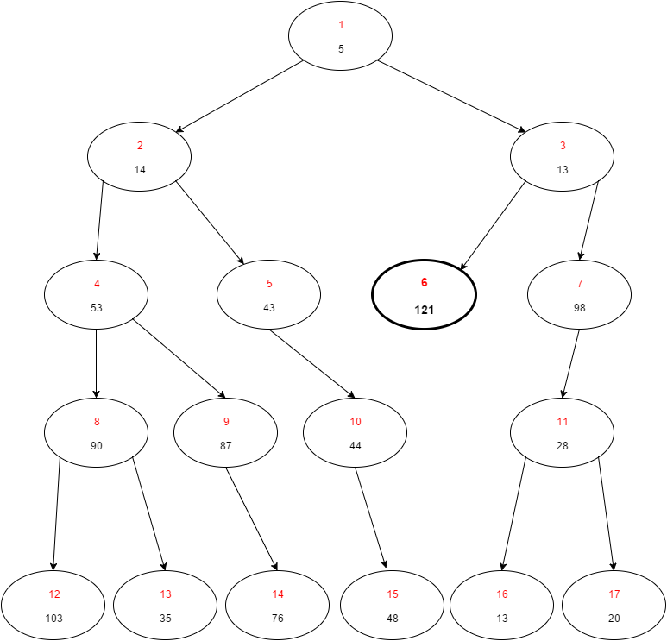

## Min-max

Up to this point we discussed solving graphs without the division for two players, we only wanted to find one node with given properties. This can be useful in many situations, but let us consider a game for two players which compete with each other.

This is where we will use a min-max algorithm. This algorithms excels in solving games where two players face each other. Min-max algorithm can find the greatest value that given player can be sure to obtain without the knowledge of what actions his opponent will perform. In other words it minimizes the maximum risk for a player.

For the sake of example let the rules of this game be as following: players move in turns, each player want to get biggest positive score, each player can make one of two moves, the game ends when any player gets +∞ points.

### Basic min-max

In the basic version of min-max algorithm, for each possible move a player can take, we check all possible moves the other player can perform and then determine what is the worst possible combination of moves. Then the player should choose a move that gives him the largest possible value of the lowest possible values. Min-max algorithm uses DFS (depth first search) strategy.

Now let us see what would the graph of this game look like.

C:\Users\Pawel\AppData\Local\Microsoft\Windows\INetCacheContent.Word\Basic minmax 1.png

The +∞ means that a player won the game, while -∞ means that he lost a game. In the ‘max’ nodes we calculate the best move for us to take and in the ‘min’ nodes we calculate the worst move for us that the other player can take.

From this graph, we can deduce that in 3 moves the player will be more likely to win than to lose, because he can obtain the position where he is 10 points ahead of the other player. Despite the fact that the player can win the game in 3 moves (see the node with value of +∞), it is unlikely for the player to win, because his opponent will not choose this path.

### Alpha-Beta cuts

There also exists improved version of min-max algorithm which is called a min-max with alpha-beta cuts or a min-max with alpha-beta pruning. It is a combination of two different variants of min-max algorithm. One of them is called alpha cuts and the other is beta cuts. Alpha cut version cuts branches where maximizer can’t find better option than in any already explored nodes along path to the root, while beta cut version cuts branches where minimizer can’t find better option. This version of the algorithm improves its performance dramatically, without affecting the result. This algorithm tries to minimalize the number of nodes to by evaluated by min-max algorithm by ‘cutting off’ nodes that are for sure worse than other previously evaluated ones. It decreases the number of decision the algorithm would take and thus increases its performance.

The following graph shows where the cuts would be performed if the graph is the same as the one previously examined.

C:\Users\Pawel\AppData\Local\Microsoft\Windows\INetCacheContent.Word\Alphabeta minmax 1.png

# Project Implementation

As a practical part of my bachelor thesis I implemented min-max algorithm in two games: Connect-four and Tic-tac-toe. In this chapter, firstly I will discuss the rules of these two games, then I will present the common min-max implementation for these two games. Next I will consider each game individually and present its heuristics, specific implementation and the results for different min-max algorithms executions. Todo: calculations on given machine (2x laptops, HP and Lenovo)



## Rules of games

### Connect-four

Rules of Connect-four game are very simple. This is a zero-sum, two-player game in which players make their moves in turns. Players are dropping ‘X’ and ‘O’ tokens from the top of the board with grid diameter of seven columns and six rows. The pieces fall straight down and stops on the first unoccupied cell of the grid. The goal of the game is to place four discs to form a line in a horizontal, vertical or diagonal direction.

Below is presented the example state of board where player who places ‘X’ tokens won the game. As we can see, four ‘X’ tokens are placed in the row.

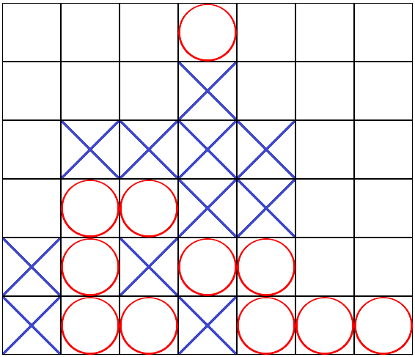

### Tic-tac-toe

Tic-tac-toe is a zero-sum, two-player game, where players make their moves in turns. One player places ‘X’ tokens and the other places ‘O’ tokens on the three by three grid board. The first players to place three tokens in the same column, row or in diagonal wins.

## Common code

During the implementation of both games, I’ve tried to design it in a way, that will be easy to add more games into the program. It means that the main logic for finding the best possible move of the algorithm remains common for all the games or at least it is easy to adapt the code to work with new type of game. The whole project is written in Java programming language.

* + 1. **Implementation**

The main part of this project is to implement Min-max algorithm and its different variations. My approach is to separate min-max algorithm from games which uses this algorithm. For the sole purpose of min-max are responsible MinMax class and Node class. Also, there are two interfaces: Board and Move.

Board interface is responsible for providing methods like evaluateBoard(int player), makeMove(Move move), generateMoves(). Board interface is later implemented by game-specific classes like ConnectFourBoard and TicTacToeBoard. These classes are responsible for storing board state. Move interface provides methods getPlayer() and getMove().

Node class holds given Board, Move, list of Node children and value of evaluated board. This class is responsible for representing the game tree. The class with core logic is MinMax class. It provides methods to generate game tree from given board state and find the best move with min-max algorithm and alpha-beta pruning.

Algorithms for generating game tree and selecting the best possible move are presented below:

|  |
| --- |
| GenerateTree(Node node, int depth){  if depth is zero or game is finished{  set value of node to heuristic value of board  return  }  for each move from possible mobes{  make move on board to create newBoard  create newNode with newBoard  add newNode as child of node  GenerateTree(newNode, depth - 1)  }  } |

|  |
| --- |
| MaxValue(Node node){  if node has no children{  return value of node  }  int bestValue = -INFINITY  for each child of node{  value = MinValue(child)  set value of child node to value  bestValue = max(bestValue, value)  }  return bestValue  }  MinValue(Node node){  if node has no children{  return value of node  }  int bestValue = +INFINITY  for each child of node{  value = MaxValue(child)  set value of child node to value  bestValue = min(bestValue, value)  }  return bestValue  } |

Method generateTree(Node, int) from snippet 1 is responsible for creating a game tree from given state of the board. It works recursively and finishes when given depth is reached or the game is either won, lost or drawn. It takes all possible moves that can be done from given board state and for each of them, algorithm generates new board after given move is made. Then, a method calls itself with newly created node and decrements depth by one. When this algorithm reaches its end, there is created a game tree from given state and with given depth.

Now let us proceed to the MinMax algorithm itself. As we can see in the snippet 2, it consists of two similar methods: MinValue and MaxValue. These two methods are called recursively in rotation. MaxValue returns the biggest value from all children of given node, while MinValue returns the lowest value from given node’s children. Thanks to this way of calling methods, at the end we obtain a game tree where each node has given value determined by a min-max algorithm. Now at the end, program should choose a child of a node, which has the highest value.

The algorithm presented above is a basic min-max algorithm. There is also enhanced version called alpha-beta cuts. Logic behind this variant was described in previous chapter. The pseudocode for this algorithm can be written as follows:

|  |
| --- |
| alphaBeta(Node node, int alpha, int beta, boolean maximizing) {  if node has no children{  return value of node  }  if maximizing player{  for each child of node{  int tempVal = alphaBeta(childNode, alpha, beta, !maximizing)  alpha = max(tempVal, alpha)  childNode.setValue(alpha);  if alpha is greater or equal to beta{  return alpha  }  }  return alpha  } else {  for each child of node{  int tempVal = alphaBeta(childNode, alpha, beta, !maximizing)  beta = min(tempVal, beta)  if alpha is greater or equal to beta {  return beta  }  }  return beta  }  } |

User has the possibility of choosing whether basic min-max, or alpha-beta pruning min-max should be used. All the source code is attached in the last chapter. Furthermore, the times of computing the best move using either algorithm are logged to a file. This will be helpful for further analysis.

## Connect-four

My implementation of Connect four game is similar to the Tic-tac-toe implementation mentioned earlier. It takes as an input one of seven possible moves, process data and display the results. The GUI is also designed similarly as in the previous game. The main part represents the current state of the board, at the bottom there are seven input buttons, and to the left there are the utility buttons.  
 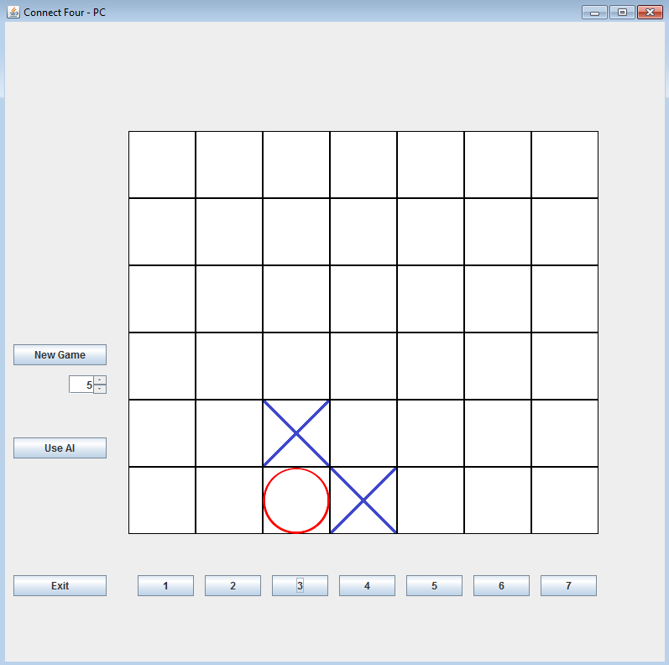

In Connect-Four game there are 42 fields on the board, so the game can take at most 42 moves and at least 7 moves. Each field can take one of 3 values (empty, player1, player2), so the upper bound of the number of possible board states is 3­42 ~~ 1020. However, many of these positions are illegal and the real upper bound is about 1012. If the algorithm was supposed to search through all these positions it would take very long time. In my implementation, user can select how many moves ahead (how deep) the algorithm should look. This functionality allows us to greatly reduce the computation time, but also reduces the accuracy of selecting the best possible move. The table below shows how the number of nodes in game tree depends on the depth.

|  |  |
| --- | --- |
| Depth | Checked moves |
| 1 | 7 |
| 3 | 343 |
| 5 | 16 807 |
| 7 | 823 543 |
| 9 | 40 353 607 |

### Heuristics

Connect-Four game is more complex game than Tic-tac-toe, so the same heuristics cannot be used. With the knowledge, that brute-forcing search would take too much time, some other heuristics need to be designed. Each two-in-row, three-in-row and four-in-row most likely approaches the player to a win of the game. Moreover, tokens placed more centrally results in more possible four-in-row moves. Thanks to this, my heuristics look like this:   
each two-in-row – value = value + 10   
each three-in-row – value = value + 100  
if there is four-in-row - value = 10000000   
each opponent’s two-in-row – value = result - 10   
each opponent’s three-in-row – value = result - 100  
if there is opponent’s four-in-row - value = -10000000

Thanks to these heuristics, all possible states of the board have their values. The algorithm does not need to compute all the moves at once, but only the given number of moves. Todo: depth

### Implementation

My Connect-Four game consists of 3 classes: ConnectFourMainWindow, ConnectFourBoard, and ConnectFourMove. Like in the previous implementation, ConnectFourMainWindow is responsible for providing proper GUI to the user, ConnectFourMove represents the move to be done. ConnectFourBoard is the core of the Connect-Four game. It implements Board interface with all its required methods.

### Results

The results for Connect-Four game are also gathered by running the program on two machines: Lenovo Y580 and HP EliteBook 840 G3.

## Tic-tac-toe

Tic-tac-toe is relatively easy game to implement. The simplest approach would be to receive one of 9 possible inputs (there are 9 fields on the board), process the data and present new state of the board to the user. In my implementation, I provided graphical user interface (GUI) which is presented below. It consists of the board representation in the top part of the window, buttons to select given tile in the bottom part of the window and few utility buttons to the left. Use AI button changes whether user wants to use AI opponent or play in turns with another user. After clicking one out of nine buttons to choose a tile, proper token is placed at corresponding tile. When either player wins the game or the game results in a draw, proper message box is displayed.

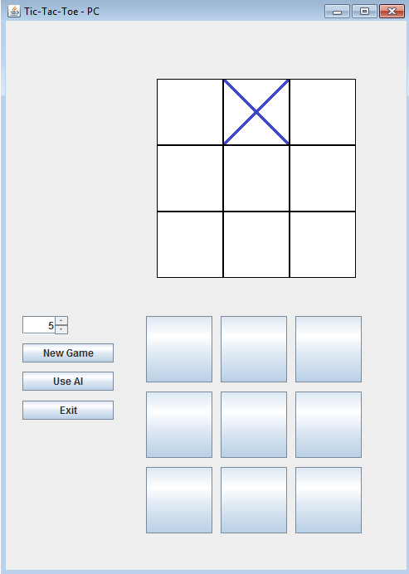 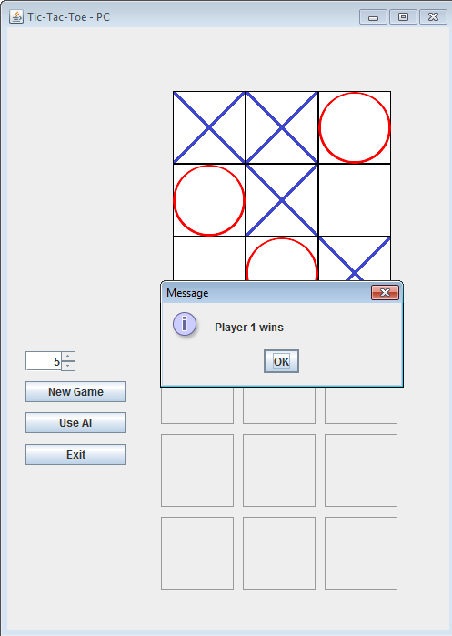

### Heuristics

As the Tic-tac-toe game is very short game, which at most lasts 9 moves, the program can quickly reach bottom of the game tree. Knowing this, it is possible to bure force the graph and the heuristics can be very simple.

if player wins the board – return **+10**  
else if player loses the board – return **-10**  
else return **0**

Because of these heuristics, only moves that results in a won or lost game have non-zero value.

### Implementation

The implementation of Tic-tac-toe game is stored in three classes: TicTacToeMainWindow, TicTacToeBoard, TicTacToeMove. The first one only works as a GUI for a user, so it only displays the window, receives an input and passes it to the TicTacToeBoard class where the whole logic lies, and displays the new, updated state of the board.

The second class is TicTacToeBoard. This class implements Board interface, so that MinMax class can operate on this class. TicTacToeBoard stores board state as a 2d array of integers with dimensions 3x3 and the player who is about to move. All methods which are provided by Board interface are properly implemented. All the source code is attached in the last chapter.

The third class is TicTacToeMove, which is just a holder class for a player and a move which he wants to perform stored as an integer.

### Results

Presented results are acquired by running my program on two machines: Lenovo Y580 and HP EliteBook 840 G3. Results are presented side by side to improve readability. Depth of the algorithm was set to 9, which is maximum value of moves to be checked in tic-tac-toe game. Below table and graph shows how many moves are possible for given move in game.

|  |  |
| --- | --- |
| Length of the game | Number of moves to be checked |
| 1 | 255 168 |
| 2 | 27 732 |
| 3 | 3 468 |
| 4 | 457 |
| 5 | 94 |
| 6 | 21 |
| 7 | 6 |
| 8 | 2 |
| 9 | 1 |

As we can notice for the tic-tac-toe game, number of moves to be checked are lowering exponentially according to the length of the game.

The table below shows how much time it takes my program to calculate which move to make. Generate Tree column says how much time it took to generate the game tree 9 moves deep. Then the MinMax column contains how much it took the algorithm to pick the best move. All the times shown in the table are in milliseconds.

|  |  |  |  |  |
| --- | --- | --- | --- | --- |
| Iteration | Depth | Generate Tree | MinMax | Sum |
| 1 | 9 | 2179.231 | 57.11445 | 2236.34587 |
| 2 | 9 | 73.93469 | 3.501338 | 77.43603 |
| 3 | 9 | 3.41568 | 0.586977 | 4.00266 |
| 4 | 9 | 0.371055 | 0.02921 | 0.40027 |
| 5 | 9 | 0.103027 | 0.007105 | 0.11013 |
| 6 | 9 | 0.044211 | 0.003553 | 0.04776 |
| 7 | 9 | 0.018948 | 0.001973 | 0.02092 |
| 8 | 9 | 0.011447 | 0.001579 | 0.01303 |
| 9 | 9 | 0.010264 | 0.001184 | 0.01145 |

Data from this table can be also presented using graph. This will be helpful later in analysis of the results.

# Analysis of results

## Connect-four

### Computational complexity

### Time complexity

## Tic-tac-toe

### Computational complexity

### Time complexity

# Conclusions

…………………………….

# References

[1] …………………………………...

[2] …………………………………...

[3] …………………………………...

[4] …………………………………...

[5] …………………………………...

[6] …………………………………...

[7] …………………………………...

[8] …………………………………...

[9] …………………………………...

[10] …………………………………...

[11] …………………………………...

[12]